House Price Prediction using Regression-based Machine Learning

Project Id: AIML-5

Name : Avika Grover (Team Leader)
Class Roll Number: 36
University Roll Number : 2028681
Section and Group: U (G2)

Name : Divya Singh
Class Roll Number: 39
University Roll Number : 2028712
Section and Group: U (G2)

Name : Rakshita
Class Roll Number: 55
University Roll Number : 2028817
Section and Group: U (G2)

TABLE OF CONTENTS
- Problem Description 3
  - Dataset Description 3
  - Flow diagram 4
- Modules for Project Implementation 5
  - ModulesUsed 5
  - PlatformUsed 6
- Machine Learning model/ Searching Technique used 7
- Evaluation metrics used 8
- Results and Visualizations 9
- Conclusion and Future Scope 12
- References 12

- Problem Description
The House Sale Price Prediction System is a regression-based machine learning project designed to estimate the selling price of residential properties using structured housing data.
In real-world scenarios, property pricing depends on many interconnected factors such as location, infrastructure, property size, nearby facilities, environmental conditions, and overall quality. Traditional estimation methods are often inconsistent and depend heavily on manual judgement.
This project aims to build a data-driven system that can learn patterns from historical housing data and generate accurate price predictions. The complete pipeline includes data understanding, preprocessing, feature transformation, dimensionality reduction, model training, evaluation, and result interpretation.
The system can be useful for buyers, sellers, real-estate agents, and developers to make better pricing decisions and understand which features influence property value the most.

1.1 Dataset Description

The dataset consists of 25 property-related input features that influence house prices.

Input Features:
- Property Area (sq ft)
- Number of Bedrooms
- Number of Bathrooms
- Number of Floors
- Year Built
- Property Age
- Renovation Status
- Lot Size
- Distance to City Center (km)
- Neighborhood Quality Score
- Crime Rate Index
- Nearby School Rating
- Hospital Proximity (km)
- Shopping Center Proximity (km)
- Public Transport Accessibility Score
- Parking Availability (Yes/No)
- Property Type (Categorical)
- Construction Quality Rating
- Energy Efficiency Score
- Water Supply Reliability Score
- Electricity Supply Reliability Score
- Internet Availability Score
- Green Space Availability Index
- Flood Risk Index
- Noise Pollution Level

Target Variable:
House Sale Price

1.2 Flow Diagram

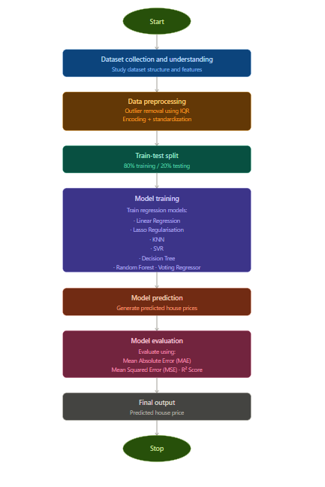

Fig.1 Flow diagram

2. Modules for Project Implementation

2.1 Modules Used

Pandas

Used for data manipulation and dataset handling.

Common functions:

read_csv() – Load dataset

head() – Display initial rows

info() – Check data types and null values

describe() – Statistical summary

isnull() – Missing value detection

NumPy

Used for numerical operations and handling arrays efficiently.

Matplotlib

Used for basic plotting and visualization.

Functions used:

plot()

scatter()

hist()

show()

Seaborn

Used for advanced visualization and better graphical representation.

Functions used:

heatmap() – Correlation matrix

Scikit-learn

Used for preprocessing, model building, and evaluation.

Functions and classes used:

train_test_split() – Splitting dataset

StandardScaler() – Feature scaling

OneHotEncoder() – Encoding categorical variables

PCA() – Dimensionality reduction

RandomForestRegressor() – Model training

VotingRegressor() – Ensemble model

r2_score() – Accuracy measure

mean_absolute_error() – Error calculation

mean_squared_error() – Error calculation

Standard Library

- Pickle — A built-in Python module used to serialize (convert to byte stream) and save trained machine learning models to a .pkl file. This allows the model to be stored permanently on disk and reloaded later for predictions without having to retrain from scratch, saving significant time and computation.

2.2 Platform Used:

- Visual Studio Code:

For code writing, testing, and debugging.
VS Code is equipped with multiple extensions, debugger which enhance the development
experience.

- Jupyter:

Used as an interactive computing environment for exploratory data analysis, visualizations, and iterative model development. Jupyter allows code to be written and executed in small, independent cells, making it easy to test individual steps of the pipeline — such as preprocessing, feature selection, and model training — without rerunning the entire script. Its inline output support for plots and tables (via matplotlib and seaborn) makes it ideal for presenting results, analyzing model performance, and documenting the workflow in a clear, readable format that combines code, output, and explanations in a single notebook file.

3. Machine Learning Model/ Searching Technique Used

- Random Forest Regressor with PCA

In this approach, Principal Component Analysis (PCA) is applied before training the model. PCA reduces the number of features by converting them into a smaller set of principal components while retaining most of the important information.

This helps in:
- Reducing dimensionality
- Removing redundant features
- Improving computational efficiency

- Random Forest Regressor without PCA

This model is trained using the original dataset after preprocessing. Random Forest works by creating multiple decision trees and combining their outputs.

Advantages:
- Handles non-linear relationships well
- Works effectively with large feature sets
- Provides feature importance

- Voting Regressor

Voting Regressor is an ensemble technique that combines predictions from multiple models and returns their average output.

This helps in:
- Improving overall prediction stability
- Reducing variance
- Achieving balanced performance

Searching Technique Used
GridSearchCV (Exhaustive Hyperparameter Search)

GridSearchCV is a systematic hyperparameter optimization technique provided by scikit-learn that automates the process of finding the best configuration for a machine learning model. The user defines a parameter grid — a dictionary specifying the hyperparameters to tune and the list of values to try for each. GridSearchCV then trains and evaluates the model for every possible combination of these parameter values using k-fold Cross-Validation, where the training data is split into k equal folds and the model is trained k times, each time using a different fold as the validation set and the remaining k-1 folds for training. The average validation score across all k folds is computed for each parameter combination, and the combination that yields the best score is selected as the optimal configuration. In this project, GridSearchCV is applied to tune hyperparameters such as the number of neighbors in KNN, the depth of Decision Trees, the number of estimators in Random Forest, and the regularization parameters of SVR — ensuring each model performs at its best before final evaluation on the test set.

4. Evaluation metrics used

1. R² Score -

R² score indicates how much variation in house prices is explained by the model. A value closer to 1 means better prediction capability.

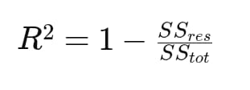

2. Mean Absolute Error (MAE) -

MAE measures the average absolute difference between actual and predicted prices. It gives a clear idea of how far predictions are from real values.

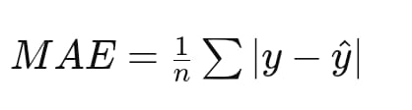

3. Mean Squared Error (MSE) -

MSE calculates the average squared difference between actual and predicted values. It penalizes larger errors more heavily, making it useful for detecting significant prediction mistakes.

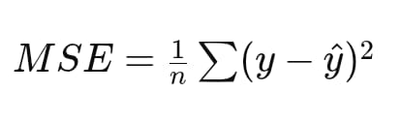

4. Root Mean Squared Error (RMSE) -

RMSE is the square root of MSE and provides error in the same unit as the target variable, making it easier to interpret.

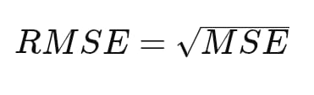

5. Cross Validation Score -

This score represents the average performance of the model across multiple folds, giving a more stable estimate compared to a single train-test split.

5. Results and Visualizations

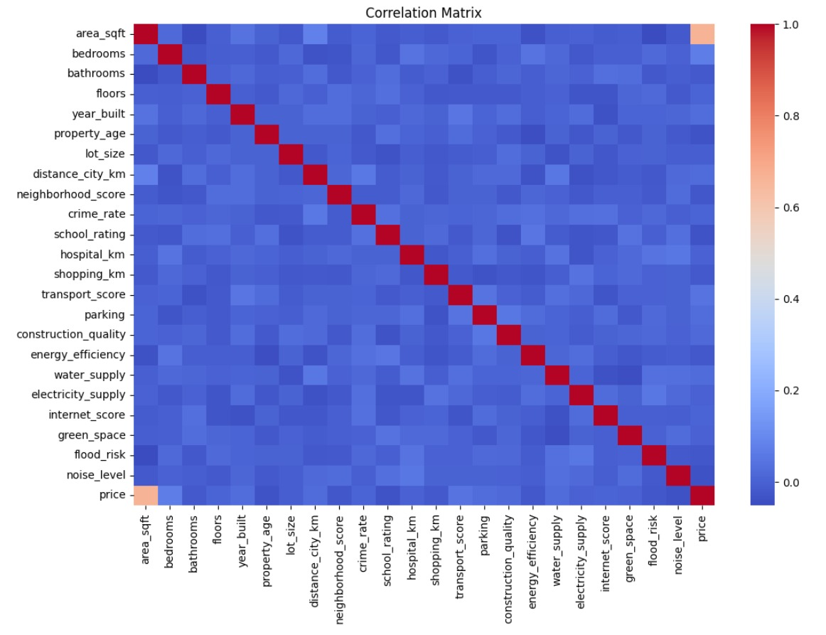

Fig.2 Heatmap showing correlation.

Inference : The correlation matrix indicates that area_sqft has the strongest positive correlation with price, making it the most significant predictor in the dataset. Most other features show weak or negligible linear relationships with each other, suggesting low multicollinearity among the remaining variables.

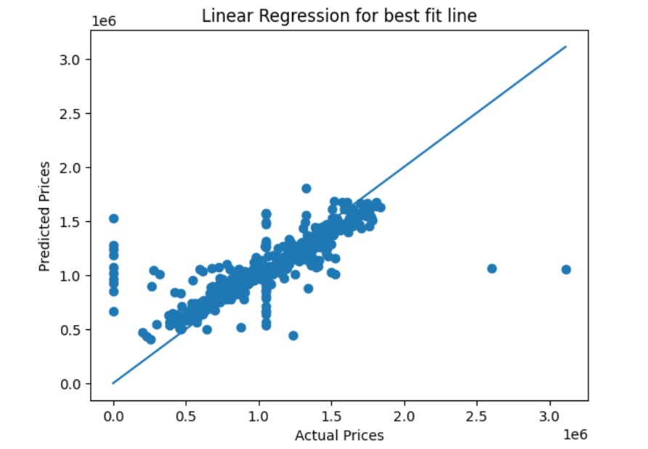

Fig.3

mean_absolute_error = 162277.73520484637
mean_squared_error = 78086607478.59805
R2_score = 0.5824963913116421

Inference : The residuals are mostly centered around zero, which shows the model captures the main data trend fairly well. However, the wide scatter and extreme outliers at higher values suggest it struggles with accuracy for more expensive properties.

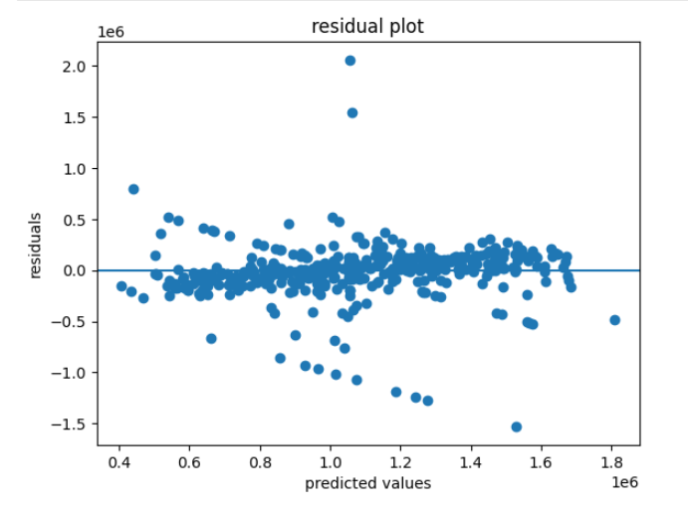

Fig.4

Inference : The plot shows a strong linear relationship where predictions closely follow the actual values, indicating a well-performing model. However, several significant outliers at the extreme ends of the price range suggest the model struggles with very low or very high-value properties.

6. Conclusion and Future Scope:

The developed system successfully predicts house sale prices using regression techniques and structured data.

Among the models used, Random Forest without PCA performed the best in terms of accuracy, while Voting Regressor provided more consistent predictions.

The project demonstrates a complete machine learning pipeline from data preprocessing to final evaluation.

Future Scope:

- Deployment as a web-based prediction system
- Integration with real-time real-estate data
- Use of advanced models like Gradient Boosting or XGBoost
- Location-based visualization using maps
- Recommendation system for property buyers

7. References:
Books:
- Hands-On Machine Learning with Scikit-Learn, Keras and TensorFlow
- Python for Data Analysis by Wes McKinney

Online Resources:
- Scikit-learn Documentation
- Pandas Documentation
- Kaggle Datasets
- GeeksforGeeks
- Stack Overflow

